EXP 17: CHANGE HARDWARE COMPATIBILITY OF A VM (EITHER BY CLONE/CREATE NEW ONE) WHICH IS ALREADY CREATED AND CONFIGURED.

AIM:
To Change Hardware compatibility of a VM (Either by clone/create new one) which is
already created and configured.
PROCEDURE:
STEP 1:GOTO VM WARE WORKSTATION.
STEP2: RIGHT CLICK THE VM AND GOTO THE SETTINGS.
STEP 3: ADD HARDWARE WIZARD AND SELECT SCSI AND CLICK NEXT.
STEP 4: CREATE NEW VIRTUAL DISK.
STEP 5: SELCT THE DISK SIZE AS 2.0. AND SELCT SPLIT VIRTUAL DISK INTO MULTIFILES.
STEP 6: GIVE NAME AND CLICK THE FINISH.

IMPLEMENTATION:

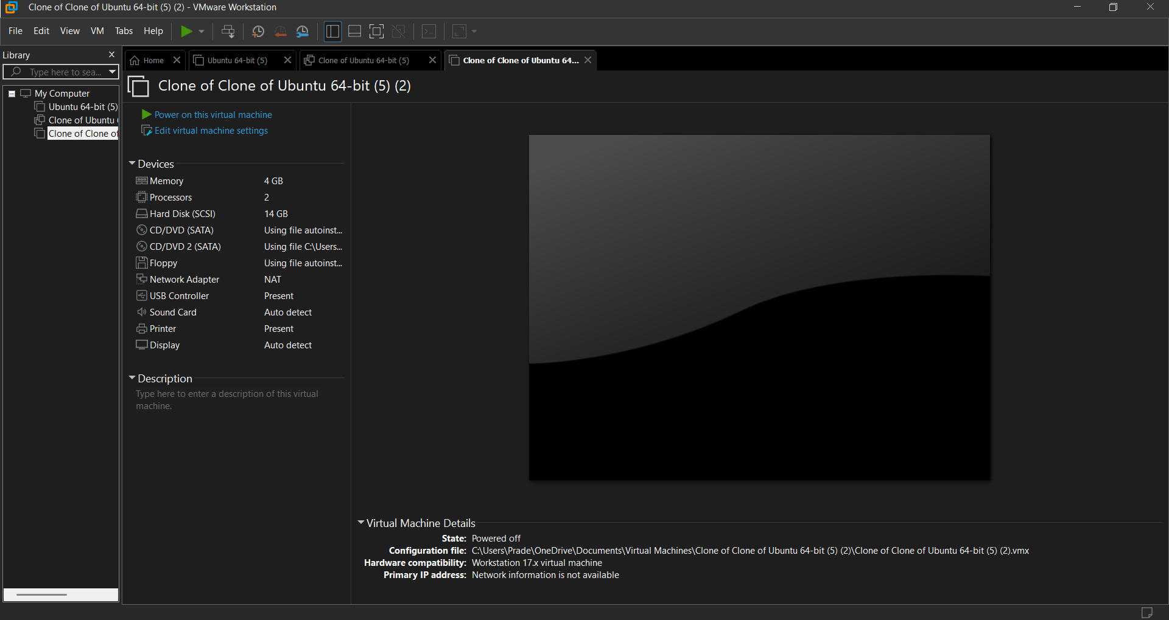
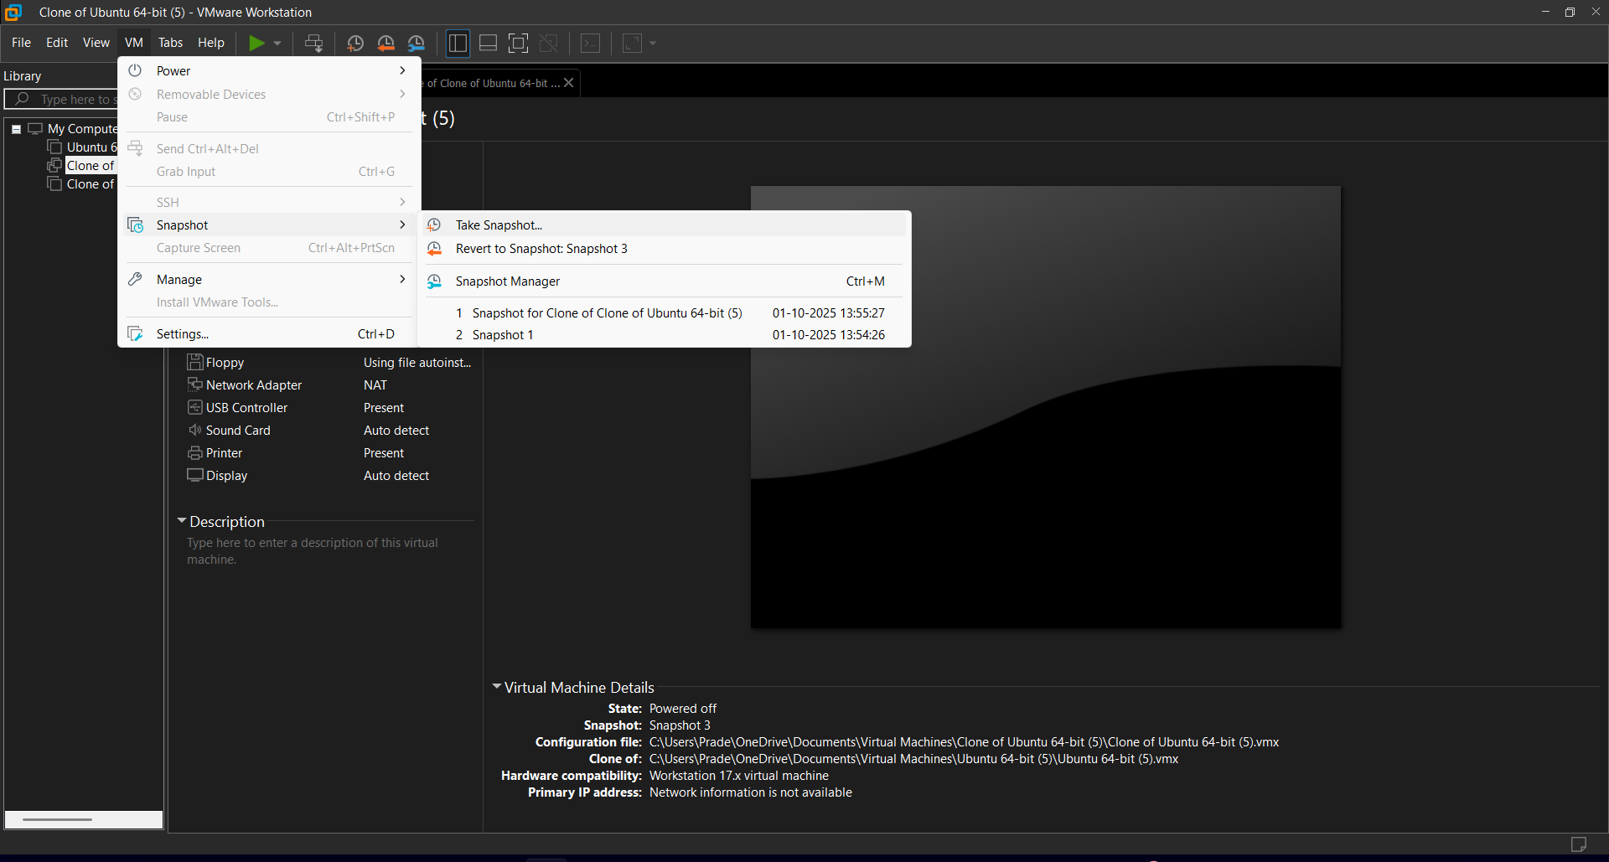

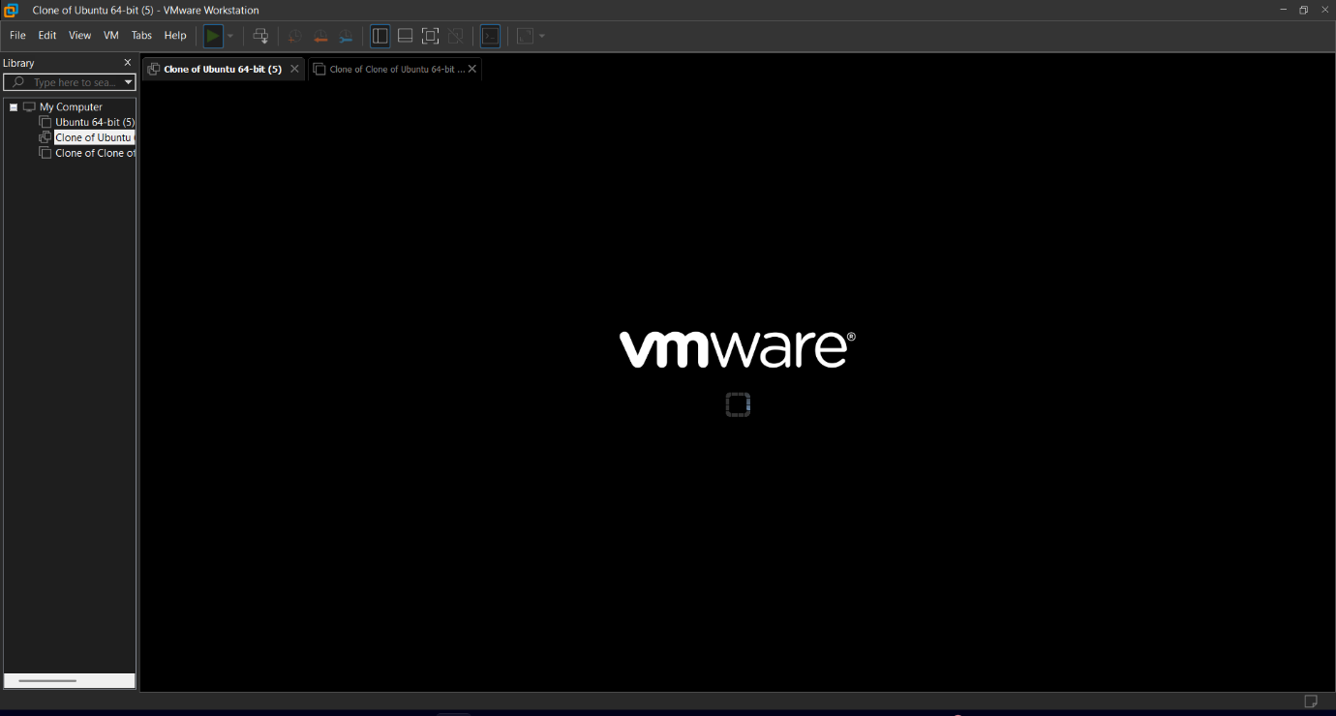
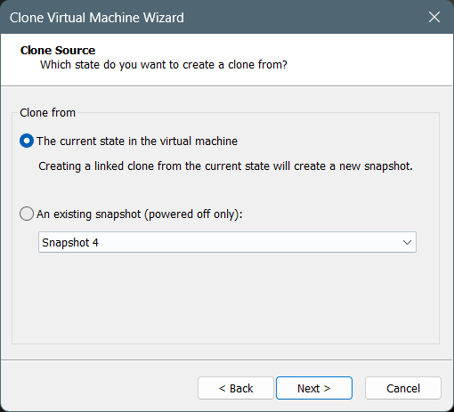

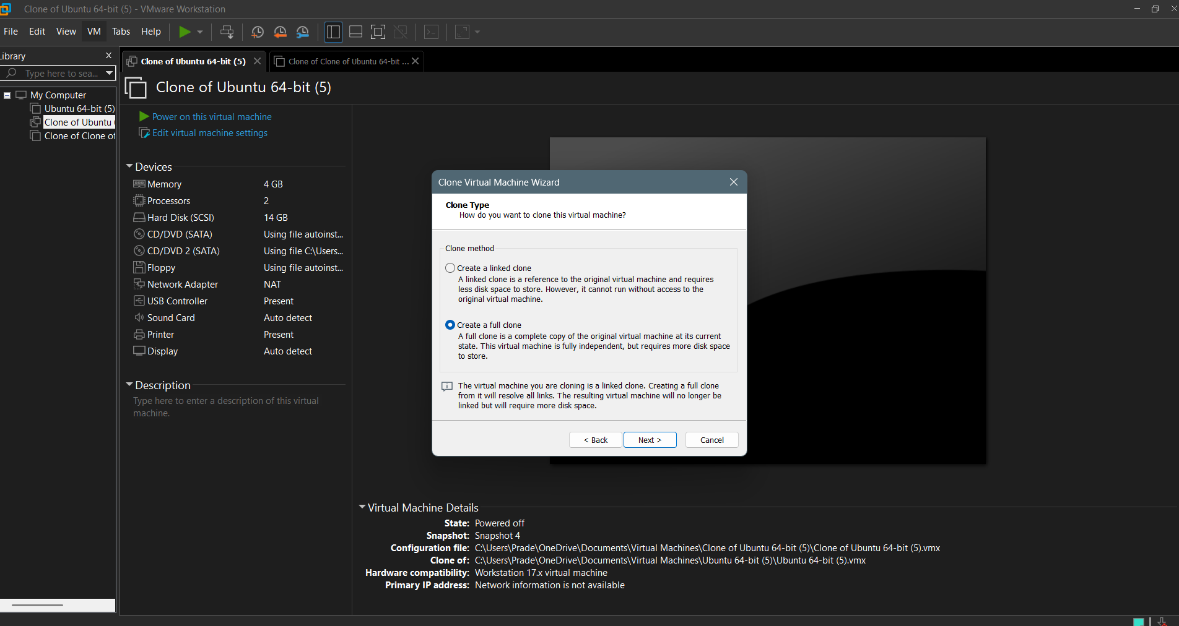

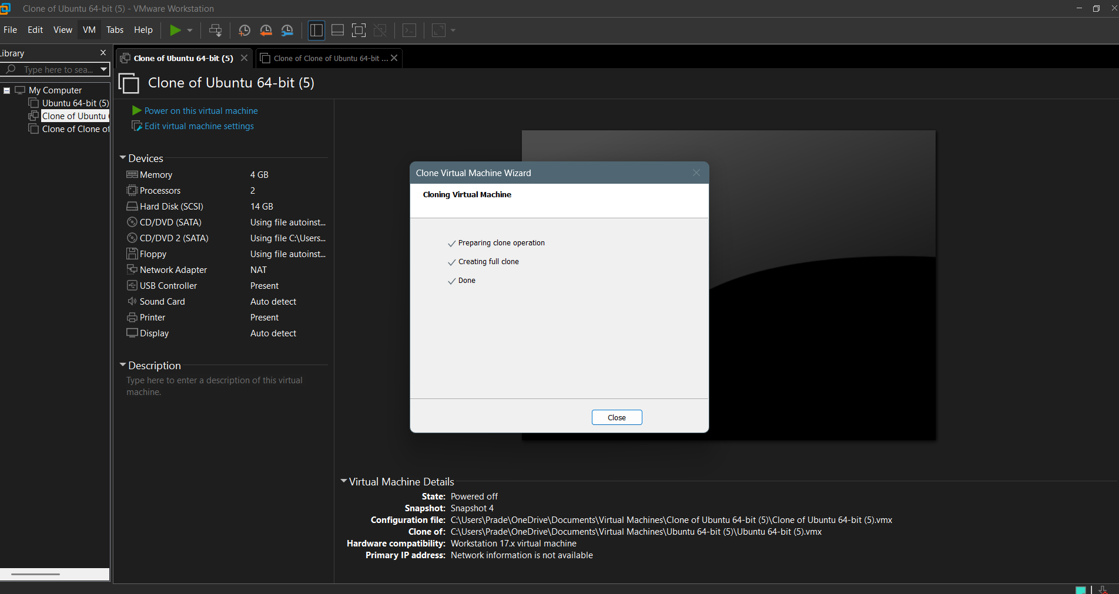
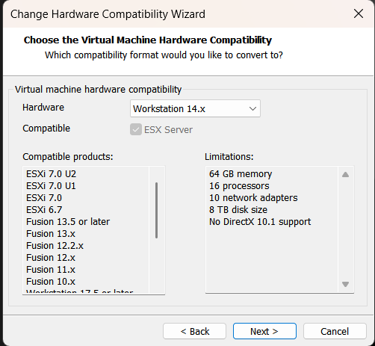

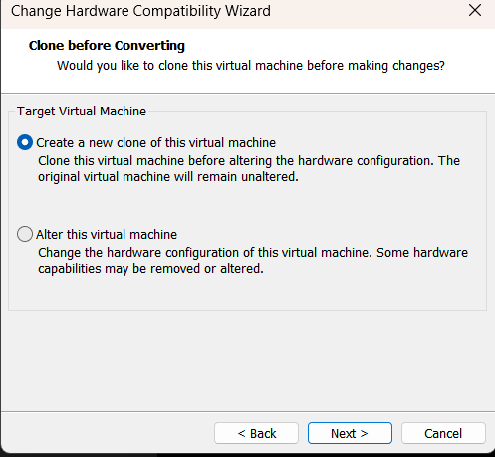
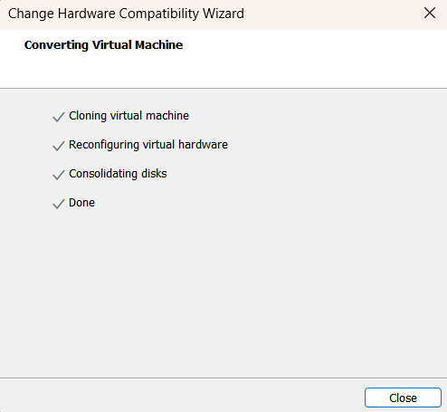

RESULT:
Hardware compatibility of a VM (Either by clone/create new one) which is
already created and configured has been changed.

